Death Traps (A Learning Activity)
This lesson plan is a scripted power point slideshow describing the process by which certain animals have died and become fossilized in waterholes, influenced by a severe period of drought. It compares two such sites, separated by 13 million years at two famous paleontological localities – Agate Fossil Beds (National Monument) in Western Nebraska, and the big Badlands (National Park) of South Dakota. Through description and analysis, and comparison of two very different locations, students will learn principles relating to the behavior, habitat and survival of living animals, as well as the scientific study of past life forms known as fossils, and severe climatic events.
The power point and script can be downloaded and used for individuals or groups. They may also supplement other science lessons, or serve as an introduction for field trips to these sites, or in contacting Agate Fossil Bed National Monument for a live, distance learning chat. The activity is geared towards the upper grades (5th and above).
Certain words have been underlined in the text as possible vocabulary words, and a key to identify most fossil animals pictured in the illustrations has been included.

DEATH TRAPS! (Fossils Found in Ancient Watering-Holes) [SLIDE 1]
A Power Point educational activity by Matt Miller (and case study in the science of taphonomy)
[SLIDE 2] Imagine you are an animal living on a vast open grassland. Small trees and bushes provide some shade. It is the wet season and it rains fairly often. Food is plentiful. The leaves are green, the fruits on the trees are ripe, and the hunting is good.
[SLIDE 3] Three months later, you are on that same grassland but it’s now the middle of the dry season. You have to stay close to the last remaining water source in the area: a small pond that slowly shrinks as the sun evaporates it away and the other animals that you share the grassland with drink it all up. More and more animals show up to this “watering-hole” as the dry season goes on. It becomes harder and harder to find any food other than meat because all the plant eating animals are devastating the bushes. Before long the plant eaters resort to eating the wood and bark off the trees and digging up roots. [SLIDE 4] You know that they will soon all die from malnutrition. Their deaths will feed you for a while, but with so many dying they will likely poison the water with bacteria. Other animals will drink the now putrefying water, get weak, and be unable to walk out of the deep mud surrounding the pond. In a month’s time there won’t be anything to eat and the only water you can drink will likely kill you. You just hope the rains come back before that happens.
You may realize that many of the pictures you are seeing are from the African savanna. But, this same story has played out for millions of years in many different parts of the world. Often the rains come soon enough and most of the animals live. At other times the rain comes too late and many animals perish. [SLIDE 5] Similarly, on the prairies of South Dakota and Nebraska, people worry about how much rain they will get in the spring for planting and hope for short winters. And it is sometimes on these same prairies, or rather in the rocks beneath them, that the buried history of earlier drought stricken death-traps can be found.
One such death trap was found in the early part of the 20th century under the prairie at Agate Fossil Beds National Monument in Nebraska. [SLIDE 6] Buried within the rock are thousands of bones from hundreds of animals that died of thirst, hunger, disease, and predators. Their bodies must have first lain in the sun. As rot and decomposition set in, the bodies would have begun to fall apart and get moved around by other animals coming to the watering-hole looking for a clean drink and finding none. When the rains finally came again, the bones were buried, hidden from the surface for 19.2 million years.
Some say “death is only the beginning” in the larger cycle of life. That is certainly true for the fossil scientists called “paleontologists,” who use fossils as a starting point to reimagine the past. Often paleontologists find only isolated fragments or a few bones of one or two individuals. On other occasions, they may discover more individuals of one or several species, many times deposited in river beds and piled up over very long periods of time. Here in this ancient death-trap at Agate Fossil Beds that was the case, and the drought that killed these animals left behind a snapshot of time.
Many people ask the questions: “How do you know it’s a watering-hole? Why couldn’t these animals have died from something else, like a flood?” To answer those questions we should start by looking closer at the animals themselves; where they were found, how their bones were oriented, and how complete they were. [SLIDE 7] During the initial excavations of the fossil bones, two species comprised the majority of the dead animals, the first being Menoceras. Menoceras was a small rhino - a relative of modern rhinos, but which lived millions of years ago. These rhinos were not quite like the ones that live in Africa and Asia today. Menoceras was small: about the size of a big dog. By looking at their teeth we know that they were herbivores eating small shrubs, bushes and grass. They lived near rivers to drink, stay cool, and roll in the muddy banks to keep away biting flies. Eventually the river dried up when the rains stopped, leaving behind only a muddy pond in the once flowing riverbed. Hundreds of Menoceras, males and females, babies and adults, all died, their bodies scavenged, broken apart and scattered all around the area. The bones stacked up, as much as 2 feet deep, and often angled into the ground at steep slopes. [SLIDE 8] Other areas have fewer remains, the bones fragmented and much more widely scattered, and lying totally flat. It’s almost like the bones filled a shallow hole … a watering-hole. More bones fit at the center of the pond than on the periphery and their steep angles indicate they were supported by thick layers of mud. Bones on the outside rim of the watering-hole that were in drier areas were more likely to lie flat. If a flood had washed the bones into this place, then they would all point in the same direction, having been aligned by the flowing water, not randomly strewn about like we see at Agate Fossil Beds.
[SLIDE 9] The bones of another ancient animal called Moropus share the layer of bones. Moropus was a chalicothere: a family of animals, now extinct, with 8 inch claws on its front, three-toed feet. It had a long neck and a horse-like face. Moropus was the size of a horse and ate plants just like the rhino Menoceras did, and likely used its big claws to dig up roots and vegetables and fight off predators. The way the bones of Moropus were distributed was both like and unlike those of the rhino Menoceras. Of the 50 to 75 Moropus found at Agate, about 15 were found nearly complete and intact; the rest were jumbled up among the Menoceras bones. What is even more interesting is that the intact Moropus bones were found on top of the deepest part of the bone pile. Why would some bones of Moropus be intact and others be scattered? We will get back to that question later.
[SLIDE 10] Besides a few fragments of other species, the only other well represented animal was the large pig-like animal Daeodon. Daeodon (also known as Dinohyus) was a massive, horse-sized animal with big teeth and a gigantic head. Like pigs, it could eat plants or meat, but unlike pigs of today, it was at the top of its food chain. Daeodon was so big that nothing else of its time could hurt it. Since it ate meat, it would have been attracted to the smell of dead and dying animals. At least two Daeodons were found away from the thick part of the bone pile on the outside rim of the bone layer where there are fewer bones, and interestingly, their bones were mostly intact. They are a bit more scattered, though, than the most intact Moropus bones. Could that be an indication of how long the bones were left to rot in the sun compared to the various death episodes of Menoceras and Moropus?
[SLIDE 11] Based on the fossils found and the evidence in the surrounding rock layers we can develop a picture of what happened here 19.2 million years ago. Water flowed in an ancient riverbed transporting silt and sand towards the Mississippi River. The wet season ended and the river began to dry up, leaving only a single pond behind. Over the next several months Menoceras herds came into the area along with a few small groups of Moropus. These animals died slowly at first as their food sources dwindled, then more quickly as the dry months wore on. As their bodies baked under the sun in the stagnant pool, the carcasses deteriorated; the muscles and ligaments that once held bones together fell apart, and the large Daeodon scattered the bones when it came to the pool looking for a drink and found a feast of dead rhinos. Eventually even the mighty Daeodon died from malnutrition, sickness or thirst and the pond became smaller and smaller, leaving only a muddy pit.
Since the Daeodons died a bit later than the Menoceras and most of the Moropus, their bones spent less time in the sun rotting before the rains came again and the stream partially buried them in sediments. With the new rains the muddy pit became a small pond again. Another small herd of Moropus trekking across the savanna found the pond and were briefly saved from dehydration. Unfortunately for them, there were no more plants around to eat and the rains did not return. The pond dried out again and the Moropus all died at the center of the muddy pit. Shortly after, the life-bringing rains finally came back, but too late to save the hundreds that died there.
This cycle of wet and dry seasons must have played out on the Great Plains for millions of years. Given that amount of time, you would think that other fossilized examples of mass deaths around ancient watering-holes might exist. Well, that is exactly what we find! Although rare, paleontologists know of other places that became such ancient death-traps.
[SLIDE 12] Badlands National Park in South Dakota is just a few hours north of Agate Fossil Beds National Monument. The cliffs and spires of the big badlands don’t look much like a grassland or savanna today. But 33 million years ago, that’s 13.8 million years older than Agate Fossil Beds, Badlands looked much different. [SLIDE 13] Grasslands had not yet widely spread on the North American continent, having only just recently evolved. The animals were different too. Rhinos were common on this savanna like they were during the time of Agate Fossil Beds. [CLICK] The rhino Subhyracodon was about the size of a deer and is a cousin of Menoceras, who evolved later. However, neither male nor female Subhyracodons had horns like most rhinos. [CLICK] Another animal was called Archaeotherium. You might notice he looks a lot like Agate’s Daeodon only much smaller, about the size of a big dog. That’s because these two are related as well. Archaeotherium lived in herds and likely hunted Subhyracodon for food to supplement their diet of plants, along with a wide variety of other animals, including the ancient horse Mesohippus and the tiny deer-like Leptomeryx. These are the major animals uncovered at Badlands in a fossil site called the “Big Pig Dig.” The bone site was given that name because of the many pig-like Archaeotherium that are abundant there. (Actually, the first bone they found, thought to be from a pig, was the rhino Subhyracodon)
[SLIDE 14] The rocks and bones of this site tell us that the landscape was warmer than at the time of Agate Fossil Beds and also more humid, but still seasonally wet and dry. During a particularly bad dry season, ground water seeped out at the surface making a small pond, similar to the one seen at Agate. A small Subhyracodon herd of about 10-12 individuals came for a drink around the same time that 25-30 Archaeotherium, and several other animals came to the watering-hole. In a matter of months, the animals all died for the same reasons that the ones at Agate Fossil Beds died. One thing we cannot say for certain, though, is what order the Big Pig Dig animals died in, like we can at Agate. All the bones were broken apart by scavengers and decay and became buried in the mud at the bottom of the pond. Over time the whole pond got buried in more sediment and preserved the fossil evidence of these animals’ lives.
[SLIDE 15] Looking at this time line of geologic history we can see that the time of the Badlands Pig Dig animals was in the early Oligocene and that the Agate Fossil Beds watering-hole occurred during the early Miocene. [CLICK] These two watering-holes suggest that the entire time interval between them may have had climates that alternated between wet and dry seasons in the Nebraska/South Dakota region, a very different climate from what we have today with our summer and winter seasons. This tells us that from the Oligocene to the Miocene the whole planet must have been warmer than it is today. Other fossil and geological information also supports this notion that the planet was much warmer during this time period and even before the time of the Pig Dig animals. (fossil turtles, coal deposits, dinosaurs? …)
[SLIDE 16] Both Agate Fossil Beds National Monument and Badlands National Park provide classic examples of life from the Miocene and Oligocene epochs. The study of ancient death traps has enhanced the field of paleontology for over a century. Through them we can see what happened in the past during a matter of months: a “snapshot of time.” In trying to study past animals’ lives through the window of scarce fossils, death is indeed only the beginning of our understanding of them.
SLIDE 1 Title with photo of a section of the recreated bonebed from the Agate Fossil Beds visitor center diorama
SLIDE 2 Lush African savanna with grass and trees
SLIDE 3 Drying waterhole with drinking African animals and no vegetation
SLIDE 4 Black and white photo of dying cows around a shrinking waterhole
SLIDE 5 Modern day University and Carnegie Hills and river valley labeled Agate Fossil Beds National Monument
SLIDE 6 Three composite photos labeled Early 20th Century excavations of Agate Fossil Beds with historic images and close-up of one of the bonebed blocks removed from the quarries
SLIDE 7 Composite skull photos and fleshed out illustrations of male and female Menoceras
SLIDE 8 Miller diagram showing “Idealized Cross-section of the Agate Bonebed”
SLIDE 9 Mounted Moropus skeletons in Agate diorama next to illustration of Moropus from Smithsonian’s Matternas mural
SLIDE 10 Mounted Daeodon in Agate diorama next to a photo of the fleshed out Dinohyus (Daeodon) from Denver Museum of Nature and Science exhibit
SLIDE 11 Matternas mural from the Smithsonian labeled “Life during the Early Miocene” and showing a variety of the fossil animals known from discoveries at Agate and its surroundings (including left to right – Moropus, oreodont, beardog, Parahippus horse, Stenomylus camel, Menoceras rhino, Syndyoceras, and Dinohyus plus others – see key)
SLIDE 12 Modern day Badlands National Park photo showing geologic badlands and grasslands
SLIDE 13 Mural from Badlands visitor center showing animals of “Badlands, 33 Million Years Ago” with rhino Subhyracodon, and entelodont Archaeotherium (aka Big Pig) highlighted
SLIDE 14 Photo of Badlands fossil excavation showing “Rib Bones found at the Big Pig Dig”
SLIDE 15 Geologic time chart showing the Cenozoic era and comparing Agate (19 mya) and Badlands (33mya) waterhole death events to the end of the dinosaurs (65mya) and the present
SLIDE 16 Concluding slide morphing from the previously introduced fossil day faunas to the present landscapes of Agate Fossil Beds National Monument and Badlands National Park
Vocabulary words: taphonomy, putrefying, savanna, predators, decomposition, species, oriented, herbivores, scavenged, chalicothere, food chain, Oligocene, Miocene
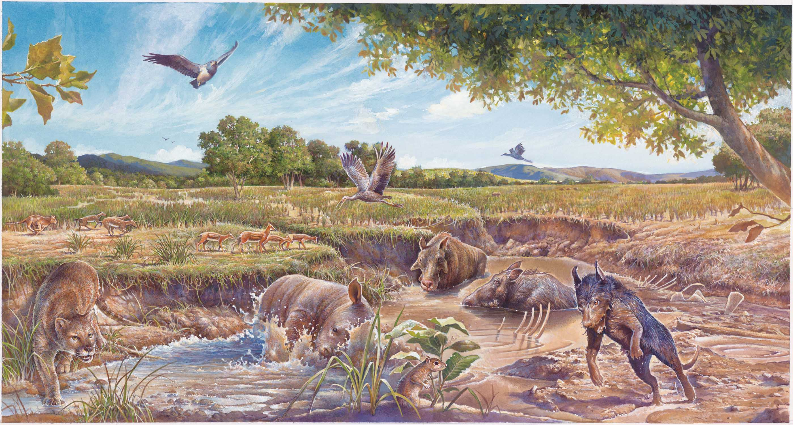
Mesohipppus Leptomeryx Archaeotherium
Nimravid Subhyracodon Daphoenus
Ischyromys
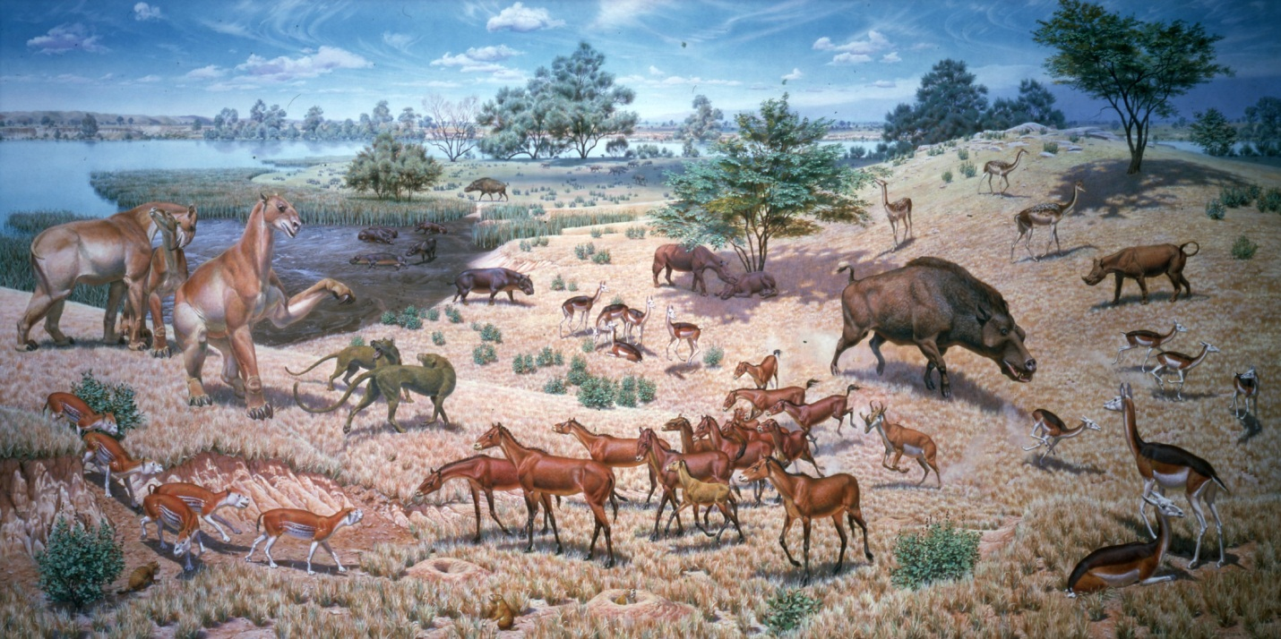
Moropus Daphoenodon Stenomylus Daeodon Menoceras
Merychyus Parahippus Syndyoceras Oxydactylus

